CS 801 INTERNET OF THINGS

1. IoT Basics + Architecture

1.1 Definition of IoT
The Internet of Things (IoT) is a network of physical devices that are connected to the internet and can collect, share, and exchange data automatically without human intervention.
These devices contain:
- Sensors
- Software
- Communication modules
- Actuators
IoT helps devices communicate with each other and make intelligent decisions.

Examples
- Smart home systems
- Smart watches
- Smart agriculture
- Smart traffic systems
- Health monitoring devices

1.2 Characteristics of IoT

i)Connectivity: IoT devices are connected through the internet or wireless networks.

ii)Intelligence: Devices can collect and analyze data to make smart decisions.

ii)Automation: Many operations happen automatically without human control.

iv)Scalability: Large numbers of devices can be connected together.

v)Dynamic Nature: IoT devices continuously change their state and data.

vi)Heterogeneity: Different devices and technologies can work together.

vii)Real-Time Communication: IoT systems provide instant communication and fast response.

1.3 IoT Architecture
IoT architecture defines how IoT devices communicate, process data, and provide services.
The basic IoT architecture contains four layers.

1.4 Diagram of IoT Architecture
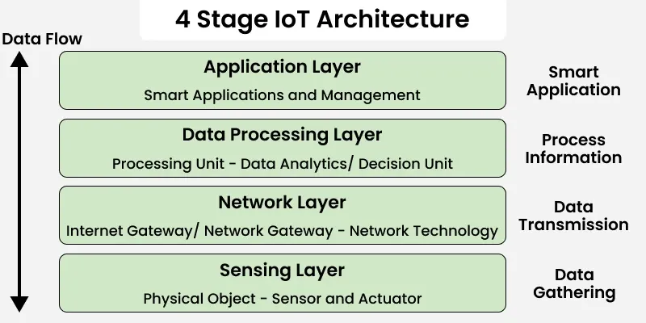

1.5 Working of IoT Architecture

1.5.1 Perception Layer
This is the physical layer of IoT.
Functions:
- Collects data from environment
- Uses sensors and devices
Examples:
- Temperature sensor
- Motion sensor
- RFID tags
The collected data is sent to the network layer.

1.5.2 Network Layer
This layer transfers data between devices and servers.
Functions:
- Data transmission
- Device communication
Technologies used:
- WiFi
- Bluetooth
- ZigBee
- 6LoWPAN
The data is forwarded to the processing layer.

1.5.3 Processing Layer
This layer processes and stores data.
Functions:
- Data analysis
- Cloud computing
- Decision making
- Database management
Technologies:
- Cloud platforms
- Big data analytics
- AI systems
After processing, useful information is sent to application layer.

1.5.4 Application Layer
This layer provides services to users.
Functions:
- Displays information
- Controls smart systems
- User interaction
Applications:
- Smart homes
- Smart cities
- Smart healthcare
- Smart farming

1.6 Components of IoT Ecosystem
Main components are:
Component | Function
Sensors | Collect data
Actuators | Perform actions
Connectivity | Connect devices
Cloud | Store and process data
User Interface | Interact with users

1.7 Advantages of IoT

a)Automation: Reduces manual work.

b)Better Efficiency: Improves system performance.

c)Real-Time Monitoring: Continuous monitoring of devices.

d)Cost Saving: Reduces operational costs.

e)Improved Decision Making: Uses data analytics for better decisions.

f)Remote Access: Devices can be controlled from anywhere.

1.8 Applications of IoT

a)Smart Home: Smart lights, fans, security systems.

b)Healthcare: Patient monitoring systems.

c)Agriculture: Smart irrigation and soil monitoring.

d)Smart Cities: Traffic management and smart parking.

e)Industrial IoT: Machine automation in industries.

f)Transportation: Connected vehicles and GPS tracking.

1.9 Conclusion
IoT is an advanced technology that connects smart devices through the internet for automatic communication and intelligent decision making.
Its architecture helps in data collection, communication, processing, and service delivery. IoT is widely used in smart homes, healthcare, agriculture, industries, and many other modern applications.

2. M2M vs IoT

2.1 Definition of M2M
M2M (Machine to Machine) is a technology in which machines or devices communicate directly with each other without human involvement.
It mainly focuses on point-to-point communication between devices using wired or wireless networks.
Examples:
- ATM machines
- Smart electricity meters
- Industrial monitoring systems
- Vending machines

2.2 Definition of IoT
IoT (Internet of Things) is a network of smart devices connected through the internet that can collect, exchange, and analyze data automatically.
IoT not only connects devices but also uses cloud computing, analytics, and intelligent decision making.
Examples:
- Smart homes
- Smart healthcare
- Smart farming
- Smart traffic systems

2.3 M2M Architecture
M2M architecture mainly contains:
- Devices/Sensors
- Communication Network
- M2M Server
- Application

Working:
- Devices collect data using sensors.
- Data is sent through wired or wireless communication.
- M2M server processes the data.
- Application performs monitoring and control.

2.4 IoT Architecture
IoT architecture contains:
- Perception Layer
- Network Layer
- Processing Layer
- Application Layer

Working:
- Sensors collect real-time data.
- Data is transferred through internet protocols.
- Cloud platforms process and analyze data.
- Applications provide smart services to users.

2.5 Difference Between M2M and IoT
Basis | M2M | IoT
Full Form | Machine to Machine | Internet of Things
Connectivity | Point-to-point communication | Internet-based communication
Network | Uses cellular or wired network | Uses internet protocols
Communication | Limited device communication | Global communication
Data Processing | Local processing | Cloud-based processing
Scalability | Limited | Highly scalable
Intelligence | Low intelligence | Smart and intelligent systems
Human Interaction | Very less | User interaction possible
Cost | Higher setup cost | More flexible and cost effective
Applications | Industrial automation | Smart homes, healthcare, cities

2.6 Reasons for Shifting from M2M to IoT

i) Internet Connectivity: IoT uses internet-based communication which allows devices to connect globally.

ii) Cloud Computing: IoT uses cloud platforms for storage and processing of huge amounts of data.

iii) Better Scalability: IoT can connect millions of devices together easily.

iv) Real-Time Analytics: IoT systems provide real-time monitoring and smart decision making.

v) Remote Access: Users can control IoT devices from anywhere using mobile or web applications.

vi) Interoperability: Different IoT devices and technologies can work together.

vii) Cost Efficiency: IoT reduces operational and maintenance costs through automation.

2.7 Advantages of M2M
a) Fast communication between machines
b) Reduces human intervention
c) Improves industrial automation
d) Reliable communication
e) Useful for monitoring systems

2.8 Advantages of IoT
a) Smart automation
b) Real-time monitoring
c) Better decision making
d) Remote device control
e) Improved efficiency
f) Large-scale connectivity

2.9 Applications of M2M
a) ATM networks
b) Industrial machines
c) Smart metering
d) Fleet tracking
e) Security systems

2.10 Applications of IoT
a) Smart homes
b) Smart healthcare
c) Smart agriculture
d) Smart cities
e) Connected vehicles
f) Industrial IoT

2.11 Conclusion
M2M and IoT both enable communication between devices, but IoT is more advanced because it uses internet connectivity, cloud computing, and intelligent data analysis.
M2M mainly focuses on direct machine communication, while IoT creates a smart ecosystem where devices, users, and applications work together efficiently.

3. IoT Levels / Communication Models

3.1 Definition of IoT Communication Model
IoT Communication Models define how IoT devices communicate with each other, servers, cloud platforms, and users.
These models help in:
- Data transfer
- Device connectivity
- Remote monitoring
- Smart decision making
Communication models are important because IoT devices continuously exchange information through networks.

3.2 Types of IoT Communication Models
There are mainly four IoT communication models:
- Request-Response Model
- Publish-Subscribe Model
- Push-Pull Model
- Exclusive Pair Model

3.3 Request-Response Model
In this model, one device sends a request and another device sends a response.
It works similar to client-server architecture.
Examples:
- Web browser requesting a webpage
- Mobile app requesting sensor data

Diagram

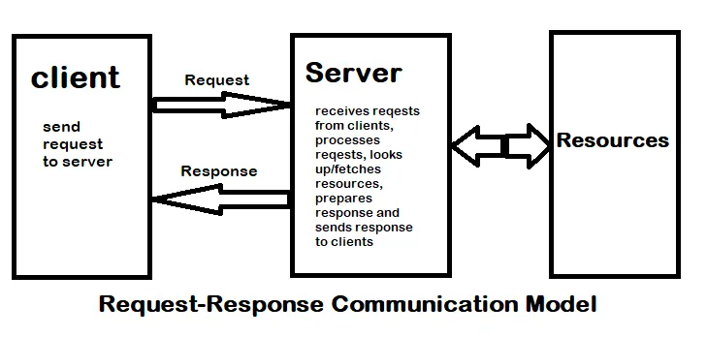

Working
- Client sends request to server.
- Server processes the request.
- Server sends response back.
- Communication ends after response.

Advantages
- Simple communication
- Easy implementation
- Reliable data transfer

Applications
- Web services
- HTTP communication
- Cloud applications

3.4 Publish-Subscribe Model
In this model, devices publish messages to a broker and subscribers receive messages from the broker.
Devices do not communicate directly.
MQTT protocol mainly uses this model.

Diagram

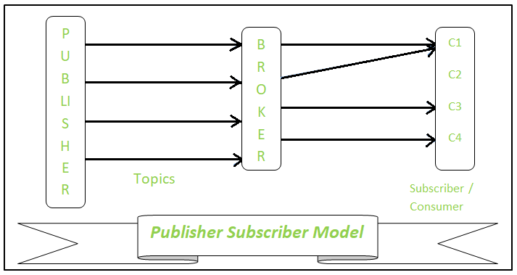

Working
- Publisher sends data to broker.
- Broker manages topics/messages.
- Subscribers receive required messages.
- Multiple devices can receive same data.

Advantages
- Efficient communication
- Scalable system
- Reduces network traffic

Applications
- Smart homes
- Sensor networks
- Real-time monitoring systems

3.5 Push-Pull Model
In this model, data producers push data while workers pull data for processing.
It is mainly used in distributed systems.

Diagram

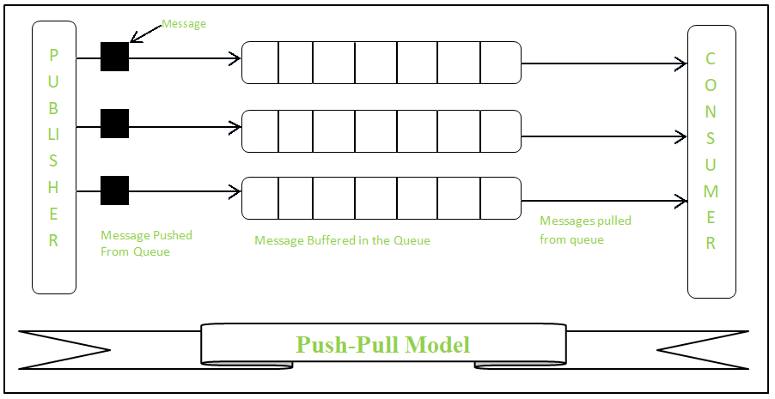

Working
- Producer pushes tasks/data into queue.
- Workers pull tasks when available.
- Tasks are processed independently.

Advantages
- Load balancing
- Fast processing
- Better resource utilization

Applications
- Big data systems
- Cloud computing
- Task scheduling systems

3.6 Exclusive Pair Model
In this model, two devices establish a permanent full-duplex communication connection.
Both devices continuously exchange data.

Diagram

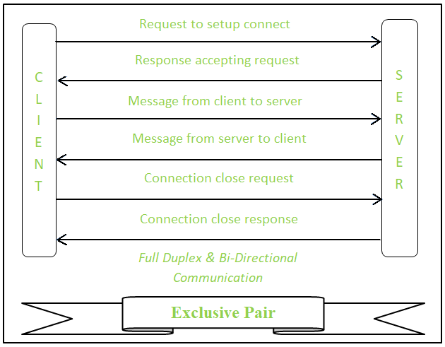

Working
- Two devices establish direct connection.
- Both send and receive data simultaneously.
- Communication remains active until disconnected.

Advantages
- Fast communication
- Continuous connection
- Low communication delay

Applications
- Bluetooth devices
- Smart wearable devices
- Real-time communication systems

3.7 IoT Levels
IoT Levels represent different complexities of IoT systems based on:
- Number of devices
- Data processing
- Cloud involvement
- Communication structure
IoT systems are generally divided into six levels.

3.8 IoT Level 1

Definition: Single node IoT system with local processing.

Working
- One device collects data.
- Data is processed locally.
- User directly controls device.

Example: Smart temperature sensor.

Advantages
- Simple design
- Low cost

3.9 IoT Level 2

Definition: Single node system with cloud connectivity.

Working
- Device sends data to cloud.
- Cloud stores and analyzes data.
- User accesses system remotely.

Example : Fitness tracking device.

Advantages
- Remote monitoring
- Cloud storage

3.10 IoT Level 3

Definition: Multiple devices connected through gateway and cloud.

Working
- Multiple sensors collect data.
- Gateway manages communication.
- Data sent to cloud for processing.
- User accesses information remotely.

Example: Smart home system.

Advantages
- Better scalability
- Centralized monitoring

3.11 IoT Level 4

Definition: Large-scale IoT system with data analytics and automation.

Working
- Large number of devices generate data.
- Cloud performs analytics.
- Automated decisions are generated.
- Real-time services are provided.

Example: Smart city system.

Advantages
- Intelligent automation
- Real-time analytics

3.12 Difference Between IoT Level 3 and Level 4
Basis | IoT Level 3 | IoT Level 4
Devices | Moderate number | Large number
Processing | Basic cloud processing | Advanced analytics
Automation | Partial automation | Full automation
Complexity | Medium | High
Example | Smart home | Smart city

3.13 Advantages of IoT Communication Models
a) Efficient data transfer
b) Real-time communication
c) Better scalability
d) Remote monitoring
e) Reduced manual work
f) Improved automation

3.14 Applications of IoT Communication Models
a) Smart homes
b) Smart healthcare
c) Industrial automation
d) Smart transportation
e) Environmental monitoring
f) Smart agriculture

3.15 Conclusion
IoT Communication Models define how devices exchange data in IoT systems. Different models are used based on system requirements such as scalability, speed, and reliability.
IoT Levels describe the complexity and architecture of IoT systems from simple single-device systems to advanced smart city infrastructures. Together, communication models and IoT levels help build efficient and intelligent IoT applications.

4. Sensors

4.1 Definition of Sensor
A Sensor is an electronic device that detects physical changes in the environment and converts them into electrical signals.
Sensors are one of the most important components of IoT systems because they collect real-world data.
Sensors can measure:
- Temperature
- Pressure
- Humidity
- Motion
- Light
- Sound
- Gas levels

4.2 Basic Components of a Sensor Node
A sensor node is a small device used in IoT and Wireless Sensor Networks (WSN).
It mainly contains the following components:
Component | Function
Sensor Unit | Collects environmental data
Processor/Microcontroller | Processes data
Memory | Stores data temporarily
Communication Unit | Sends data to other devices
Power Supply | Provides energy to the node

4.3 Diagram of Sensor Node
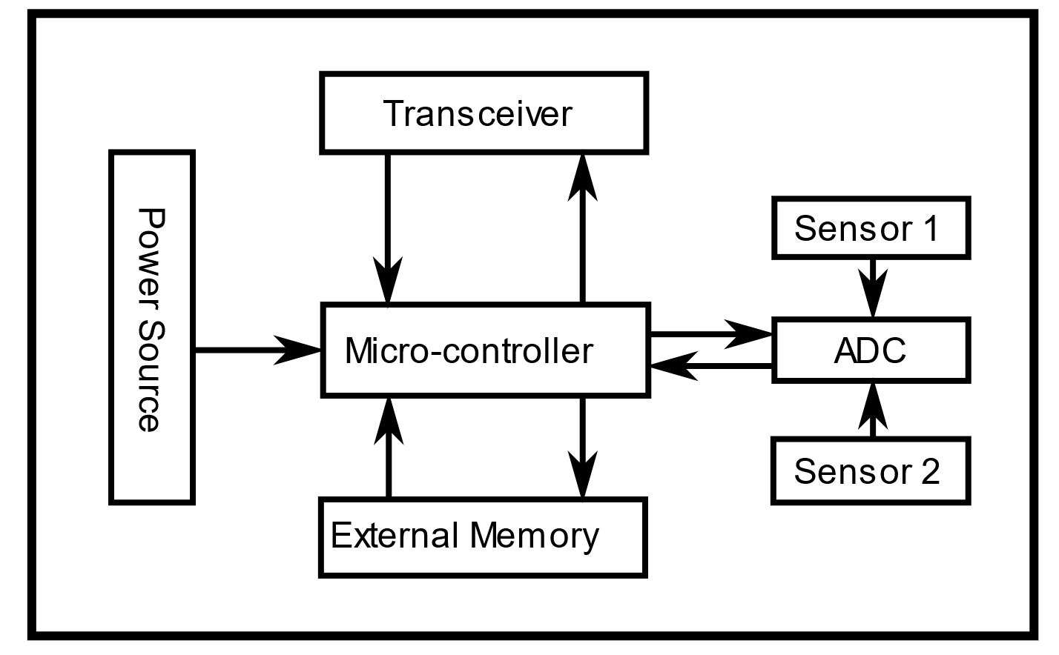

4.4 Working of Sensor
- Sensor detects physical changes from the environment.
- It converts physical quantity into electrical signals.
- The processor analyzes the signal.
- Data is transmitted through communication modules.
- IoT systems use the data for monitoring and automation.
Example: A temperature sensor measures room temperature and sends data to a smart AC system.

4.5 Features of Sensors

i) Sensitivity: Ability of sensor to detect small changes in input.

ii) Accuracy: How close the measured value is to the actual value.

iii) Resolution: Smallest change a sensor can detect.

iv) Range: Minimum and maximum values measurable by sensor.

v) Response Time: Time taken by sensor to react to changes.

vi) Stability: Ability to provide consistent output over time.

vii) Reliability: Ability to work correctly for long durations.

4.6 Sensor Resolution
Sensor Resolution is the smallest detectable change in measured quantity.
Higher resolution means:
- Better precision
- More accurate readings
Example: If a temperature sensor detects changes of 0.1°C, then its resolution is 0.1°C.

4.7 Types of Sensors
Sensors are mainly classified into four categories.
4.7.1 Analog Sensors
These sensors produce continuous output signals.

Examples
- Temperature sensor
- Pressure sensor

Advantages
- Simple design
- Low cost

Applications
- Industrial systems
- Environmental monitoring

4.7.2 Digital Sensors
These sensors produce discrete digital signals.

Examples
- Digital humidity sensor
- Motion detector

Advantages
- High accuracy
- Easy interfacing with microcontrollers

Applications
- Smart devices
- Embedded systems

4.7.3 Scalar Sensors
These sensors measure only magnitude.

Examples
- Temperature sensor
- Pressure sensor

Features
- Simple measurement
- Single value output

4.7.4 Vector Sensors
These sensors measure magnitude and direction.

Examples
- Accelerometer
- Gyroscope

Applications
- Robotics
- Navigation systems

4.8 Comparison Between Analog and Digital Sensors
Basis | Analog Sensor | Digital Sensor
Output | Continuous signal | Digital signal
Accuracy | Lower | Higher
Noise | More affected | Less affected
Processing | Difficult | Easy
Cost | Lower | Higher

4.9 Common Sensor Errors

i) Bias: Constant error added to output measurements.

ii) Drift: Gradual change in sensor output over time.

iii) Hysteresis Error: Difference in output for increasing and decreasing input values.

iv) Quantization Error: Error caused during conversion of analog signal into digital form.

4.10 Applications of Sensors in IoT

a) Smart Home
- Smart lighting
- Smart security systems

b) Healthcare
- Heart rate monitoring
- Body temperature monitoring

c) Agriculture
- Soil moisture sensing
- Weather monitoring

d) Industrial Automation
- Machine monitoring
- Safety systems

e) Smart Cities
- Traffic monitoring
- Pollution detection

4.11 Advantages of Sensors
a) Real-time monitoring
b) Automatic data collection
c) Improved accuracy
d) Reduced human effort
e) Better decision making
f) Increased automation

4.12 Challenges of Sensor Nodes
a) Limited battery power
b) Limited memory and processing
c) Communication issues
d) Security problems
e) Environmental interference

4.13 Conclusion
Sensors are the foundation of IoT systems because they collect data from the physical environment and convert it into useful information.
Different types of sensors are used for different applications such as healthcare, smart homes, industries, and agriculture. Their accuracy, sensitivity, and reliability make IoT systems intelligent and automated.

5. Actuators

5.1 Definition of Actuator
An Actuator is a device that converts electrical, hydraulic, pneumatic, or thermal energy into physical movement or action.
In IoT systems, actuators perform actions based on the data received from sensors or control systems.
Sensors collect data, while actuators perform operations.
Examples:
- Electric motor
- Water pump
- Smart door lock
- Robotic arm
- Automatic fan

5.2 Role of Actuators in IoT
Actuators help IoT systems interact with the physical world.
Main roles:
- Perform automatic actions
- Control machines and devices
- Convert control signals into motion
- Improve automation systems
Example: If a temperature sensor detects high temperature, the actuator automatically turns ON the cooling fan.

5.3 Basic Working of Actuator
- Sensor collects environmental data.
- Controller or microcontroller processes the data.
- Control signal is sent to actuator.
- Actuator converts energy into physical action.
- Desired operation is performed.

5.4 Diagram of Actuator Working
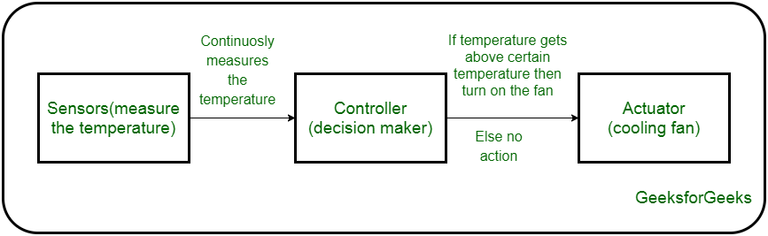
Example: Temperature Sensor → Microcontroller → Fan Motor → Cooling

5.5 Types of Actuators
Actuators are classified based on the source of energy used.
Main types:
- Hydraulic Actuator
- Pneumatic Actuator
- Electrical Actuator
- Thermal/Magnetic Actuator
- Mechanical Actuator
- Soft Actuator

5.5.1 Hydraulic Actuator

Definition: Hydraulic actuators use liquid pressure to generate movement.

Working: Pressurized fluid moves pistons or cylinders to create mechanical motion.

Advantages
- High force generation
- Smooth operation

Applications
- Heavy machinery
- Construction equipment
- Industrial robots

5.5.2 Pneumatic Actuator

Definition: Pneumatic actuators use compressed air to produce motion.

Working: Compressed air enters the cylinder and moves the piston.

Advantages
- Fast response
- Simple design
- Low maintenance

Applications
- Industrial automation
- Air brakes
- Packaging machines

5.5.3 Electrical Actuator

Definition: Electrical actuators use electrical energy to generate movement.

Examples
- DC motor
- Servo motor
- Stepper motor

Advantages
- High accuracy
- Easy control
- Energy efficient

Applications
- Smart home devices
- Robotics
- IoT automation systems

5.5.4 Thermal/Magnetic Actuator

Definition: These actuators use heat or magnetic fields for movement.

Working: Temperature or magnetic force creates expansion or movement.

Applications
- Magnetic relays
- Automatic switches
- Temperature control systems

5.5.5 Mechanical Actuator

Definition: Mechanical actuators convert rotary motion into linear motion using gears or pulleys.

Advantages
- Simple structure
- Reliable operation

Applications
- Machine tools
- Industrial systems

5.5.6 Soft Actuator

Definition: Soft actuators are flexible actuators made using soft materials like polymers.

Features
- Flexible movement
- Lightweight
- Safe for human interaction

Applications
- Medical robotics
- Artificial muscles
- Wearable devices

5.6 Comparison Between Hydraulic, Pneumatic, and Electrical Actuators
Basis | Hydraulic | Pneumatic | Electrical
Energy Source | Liquid pressure | Compressed air | Electricity
Force Output | Very high | Medium | Medium
Speed | Moderate | Fast | Fast
Accuracy | Medium | Medium | High
Maintenance | High | Low | Low
Applications | Heavy machines | Automation | Smart devices

5.7 Characteristics of Actuators Used for Selection

i) Accuracy: Ability to perform precise movement.

ii) Speed: Time taken to perform action.

iii) Power Consumption: Amount of energy required.

iv) Load Capacity: Maximum load actuator can handle.

v) Reliability: Ability to work continuously without failure.

vi) Cost: Installation and maintenance cost.

5.8 Advantages of Actuators
a) Automation of systems
b) Fast operation
c) Reduced human effort
d) Improved efficiency
e) Better control systems
f) High precision operations

5.9 Applications of Actuators in IoT

a) Smart Home
- Automatic doors
- Smart curtains
- Smart fans

b) Industrial Automation
- Robotic arms
- Conveyor systems

c) Healthcare
- Medical robots
- Prosthetic devices

d) Agriculture
- Smart irrigation systems

e) Transportation
- Automatic braking systems

5.10 Challenges of Actuators
a) Power consumption
b) Maintenance requirements
c) Heat generation
d) Limited life span
e) Mechanical wear and tear

5.11 Conclusion
Actuators are important output devices in IoT systems that convert control signals into physical actions.
Different types of actuators such as hydraulic, pneumatic, electrical, and soft actuators are used in industries, smart homes, healthcare, and automation systems. They help make IoT systems intelligent, automatic, and efficient.

6. RFID

6.1 Definition of RFID
RFID (Radio Frequency Identification) is a wireless communication technology used to identify and track objects using radio waves.
RFID systems automatically collect data without physical contact or direct visibility.
It is widely used in IoT for smart identification and tracking of objects.
Examples:
- Smart ID cards
- Toll collection systems
- Product tracking in malls
- Inventory management
- Smart attendance systems

6.2 Components of RFID System
An RFID system mainly consists of three components.
Component | Function
RFID Tag | Stores information about object
RFID Reader | Reads data from RFID tags
Antenna | Transfers radio signals

6.3 Diagram of RFID System
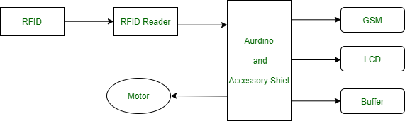

6.4 Working Principle of RFID
- RFID reader sends radio frequency signals through antenna.
- RFID tag receives the signal.
- Tag sends stored information back to reader.
- Reader transfers data to computer/database.
- System processes and displays information.
Example: In shopping malls, RFID tags attached to products help in automatic billing and tracking.

6.5 Types of RFID Tags
RFID tags are mainly classified into three types.
6.5.1 Passive RFID Tag

Definition: Passive tags do not contain their own power source.They receive power from RFID reader signals.

Features
- Low cost
- Small size
- Limited range

Applications
- Smart cards
- Library systems
- Inventory tracking

6.5.2 Active RFID Tag

Definition: Active tags contain their own battery.

Features
- Long communication range
- Faster communication
- More expensive

Applications
- Vehicle tracking
- Industrial monitoring
- Military systems

6.5.3 Semi-Passive RFID Tag

Definition: Semi-passive tags contain a battery but use reader signals for communication.

Features
- Better performance than passive tags
- Medium range

Applications
- Environmental monitoring
- Medical devices

6.6 RFID Frequencies
Frequency Type | Range | Applications
Low Frequency (LF) | Short range | Access control
High Frequency (HF) | Medium range | Smart cards
Ultra High Frequency (UHF) | Long range | Supply chain management

6.7 Features of RFID

i) Wireless Communication: No physical connection required.

ii) Fast Identification: Objects can be identified quickly.

iii) Automatic Data Collection: No manual scanning required.

iv) Multiple Tag Reading: Reader can read many tags simultaneously.

v) High Security: Encrypted RFID systems improve security.

vi) Real-Time Tracking: Tracks objects continuously.

6.8 Advantages of RFID
a) Faster object tracking
b) Contactless communication
c) Reduced human effort
d) Improved inventory management
e) Better accuracy
f) Real-time monitoring

6.9 Disadvantages of RFID
a) High installation cost
b) Signal interference problems
c) Security and privacy concerns
d) Limited performance near metal/liquid surfaces

6.10 Applications of RFID in IoT

a) Smart Retail
- Automatic billing
- Inventory tracking

b) Transportation
- Toll collection systems
- Vehicle tracking

c) Healthcare
- Patient identification
- Medical equipment tracking

d) Smart Agriculture
- Animal tracking
- Supply chain monitoring

e) Security Systems
- Smart access cards
- Attendance systems

f) Logistics and Supply Chain
- Package tracking
- Warehouse management

6.11 RFID and IoT Relationship
RFID is an important technology in IoT because it helps identify and track physical objects connected to the internet.

Role of RFID in IoT
- Object identification
- Real-time tracking
- Automatic data collection
- Smart inventory management
Example: In smart warehouses, RFID tags track products and send information to cloud systems through IoT networks.

6.12 Comparison Between Barcode and RFID
Basis | Barcode | RFID
Communication | Optical scanning | Radio waves
Line of Sight | Required | Not required
Reading Speed | Slow | Fast
Data Storage | Less | More
Multiple Reading | Not possible | Possible
Cost | Low | Higher

6.13 Challenges of RFID
a) Security issues
b) Signal collision
c) High deployment cost
d) Privacy concerns
e) Interference from environment

6.14 Conclusion
RFID is an important wireless identification technology used in IoT systems for tracking and managing objects automatically.
It improves automation, inventory control, security, and real-time monitoring in various fields such as retail, healthcare, transportation, and smart industries.

7. Wireless Sensor Network (WSN)

7.1 Definition of Wireless Sensor Network (WSN)
A Wireless Sensor Network (WSN) is a network of small sensor nodes that collect environmental data and communicate wirelessly with each other.
These sensor nodes work together to monitor physical conditions like:
- Temperature
- Humidity
- Pressure
- Motion
- Light
- Sound
WSN is one of the important technologies used in IoT systems.

7.2 Components of WSN
A Wireless Sensor Network mainly consists of the following components.
Component | Function
Sensor Node | Collects environmental data
Microcontroller | Processes collected data
Communication Module | Transfers data wirelessly
Power Supply | Provides energy to sensor nodes
Sink Node/Base Station | Collects data from all nodes

7.3 Diagram of WSN
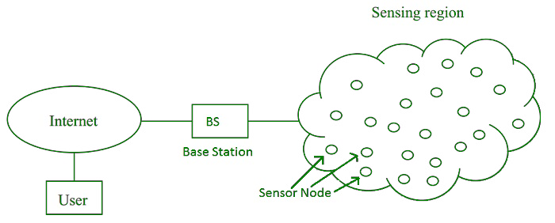Multiple sensor nodes communicate wirelessly and send data to a central base station.

7.4 Working of WSN
- Sensor nodes collect data from the environment.
- Data is processed by microcontrollers.
- Nodes communicate wirelessly with nearby nodes.
- Data reaches the sink node or base station.
- Base station sends data to cloud/server for analysis.
- Users monitor and control the system remotely.
Example: In smart agriculture, sensor nodes monitor soil moisture and temperature.

7.5 Characteristics of WSN

i) Wireless Communication: Sensor nodes communicate without physical cables.

ii) Self-Organizing Network: Nodes automatically connect and organize themselves.

iii) Low Power Consumption: Sensor nodes are designed to consume less energy.

iv) Scalability: Large numbers of sensor nodes can be added.

v) Distributed System: Multiple nodes work together for monitoring.

vi) Real-Time Monitoring: Provides continuous monitoring of environment.

7.6 Types of WSN

7.6.1 Terrestrial WSN
Sensor nodes are deployed on land.

Applications
- Environmental monitoring
- Forest fire detection

7.6.2 Underground WSN
Sensor nodes are placed underground.

Applications
- Mining systems
- Underground pipeline monitoring

7.6.3 Underwater WSN
Sensor nodes work underwater.

Applications
- Ocean monitoring
- Water pollution detection

7.6.4 Multimedia WSN
Used for audio, image, and video data collection.

Applications
- Surveillance systems
- Traffic monitoring

7.6.5 Mobile WSN
Sensor nodes can move from one place to another.

Applications
- Military systems
- Vehicle tracking

7.7 Architecture of WSN
The architecture of WSN mainly contains:
- Sensor Nodes
- Communication Network
- Sink Node/Base Station
- Cloud or Server
- User Applications

Working
- Sensor nodes collect data.
- Data travels through wireless communication.
- Sink node gathers all information.
- Cloud analyzes the data.
- Users access data through applications.

7.8 Relation Between WSN and IoT
WSN acts as a sensing technology for IoT systems.

Role of WSN in IoT
- Collects real-time environmental data
- Enables smart monitoring
- Connects physical world to internet
- Supports automation systems
Example: In smart cities, WSN sensors monitor traffic and pollution levels and send data to IoT cloud platforms.

7.9 Advantages of WSN
a) Easy installation
b) Wireless communication
c) Real-time monitoring
d) Low maintenance
e) Scalable network
f) Suitable for remote areas

7.10 Disadvantages of WSN
a) Limited battery life
b) Security issues
c) Limited processing power
d) Communication interference
e) Limited communication range

7.11 Applications of WSN

a) Smart Agriculture
- Soil monitoring
- Irrigation control

b) Healthcare
- Patient monitoring systems

c) Military
- Border surveillance
- Battlefield monitoring

d) Environmental Monitoring
- Weather monitoring
- Pollution detection

e) Smart Homes
- Security systems
- Energy management

f) Industrial Automation
- Machine monitoring
- Fault detection

7.12 Comparison Between WSN and Traditional Networks
Basis | WSN | Traditional Network
Communication | Wireless | Mostly wired
Power Consumption | Low | High
Deployment | Easy | Difficult
Cost | Lower | Higher
Mobility | Supported | Limited
Network Size | Large sensor nodes | Limited devices

7.13 Challenges in WSN

i) Energy Management: Battery replacement is difficult.

ii) Security: Networks are vulnerable to attacks.

iii) Data Loss: Wireless communication may cause packet loss.

iv) Scalability: Managing large networks is difficult.

v) Environmental Conditions: Weather and obstacles affect communication.

7.14 Conclusion
Wireless Sensor Networks (WSN) are an important part of IoT systems that help in collecting and transmitting environmental data wirelessly.
WSN provides real-time monitoring, automation, and smart communication in applications such as agriculture, healthcare, industries, military, and smart cities.

8. ZigBee

8.1 Definition of ZigBee
ZigBee is a wireless communication technology based on the IEEE 802.15.4 standard used for low-power, low-cost, and short-range communication in IoT systems.
It is mainly designed for:
- Wireless sensor networks
- Home automation
- Industrial monitoring
- Smart devices
ZigBee supports communication between multiple devices with low power consumption.

8.2 Features of ZigBee

i) Low Power Consumption: Consumes very little battery power.

ii) Low Cost: Implementation cost is low compared to other wireless technologies.

iii) Short Range Communication: Works within short distances.

iv) Mesh Networking: Devices can communicate through multiple nodes.

v) High Scalability: Large number of devices can connect together.

vi) Reliable Communication: Provides stable and secure communication.

vii) Supports Multiple Topologies: Supports star, mesh, and tree networks.

8.3 ZigBee Architecture
ZigBee architecture mainly contains four layers:
- Physical Layer
- MAC Layer
- Network Layer
- Application Layer

8.4 Diagram of ZigBee Architecture
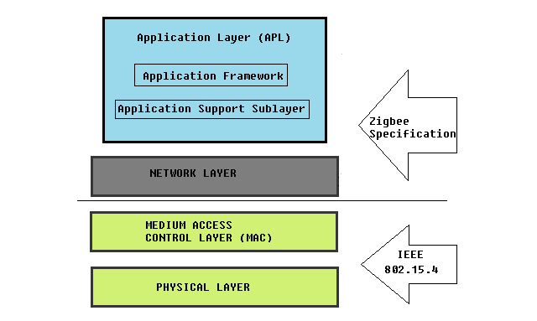

8.5 Working of ZigBee Architecture

8.5.1 Physical Layer

Functions
- Data transmission
- Signal modulation
- Frequency selection

Features
- Operates on radio frequencies
- Supports wireless communication

8.5.2 MAC Layer

Functions
- Channel access control
- Error checking
- Reliable communication

Features
- Reduces data collision
- Manages communication between nodes

8.5.3 Network Layer

Functions
- Routing of data
- Network formation
- Device connection management

Features
- Supports mesh networking
- Provides secure communication

8.5.4 Application Layer

Functions
- User applications
- Device control
- Data management

Applications
- Smart home systems
- Industrial automation

8.6 Types of ZigBee Devices
ZigBee network mainly contains three types of devices.
Device Type | Function
ZigBee Coordinator | Controls the entire network
ZigBee Router | Transfers data between devices
ZigBee End Device | Collects or receives data

8.7 ZigBee Network Topologies

8.7.1 Star Topology
All devices communicate through a central coordinator.

Advantages
- Simple network structure
- Easy management

Disadvantages
- Failure of coordinator affects network

8.7.2 Tree Topology
Devices are connected in hierarchical structure.

Advantages
- Better scalability

Applications
- Industrial monitoring

8.7.3 Mesh Topology
Devices communicate through multiple paths.

Advantages
- Reliable communication
- Self-healing network

Applications
- Smart cities
- Large IoT systems

8.8 Working of ZigBee Network
- ZigBee coordinator creates the network.
- Routers connect devices and transfer data.
- End devices collect sensor data.
- Data is transmitted wirelessly.
- Destination device receives information.
Example: In smart homes, ZigBee connects lights, fans, and sensors for automation.

8.9 Advantages of ZigBee
a) Low power consumption
b) Low cost implementation
c) Easy installation
d) Supports large networks
e) Reliable communication
f) Secure data transfer

8.10 Disadvantages of ZigBee
a) Low data transfer rate
b) Limited communication range
c) Not suitable for high bandwidth applications
d) Can face interference from WiFi networks

8.11 Applications of ZigBee

a) Smart Home
- Smart lighting
- Smart security systems

b) Industrial Automation
- Machine monitoring
- Process control

c) Healthcare
- Patient monitoring systems

d) Smart Agriculture
- Soil monitoring
- Smart irrigation

e) Smart Energy Systems
- Smart meters
- Energy management

8.12 Comparison Between ZigBee, Bluetooth, and WiFi
Basis | ZigBee | Bluetooth | WiFi
Power Consumption | Very low | Low | High
Range | Short | Short | Medium
Data Rate | Low | Medium | High
Cost | Low | Medium | High
Applications | IoT devices | Mobile devices | Internet access

8.13 IEEE 802.15.4 and ZigBee
IEEE 802.15.4 is the standard used for low-rate wireless personal area networks (LR-WPAN).
ZigBee uses IEEE 802.15.4 for:
- Physical layer
- MAC layer communication

Role in IoT
- Enables low-power wireless communication
- Supports IoT sensor networks
- Provides reliable short-range communication

8.14 Challenges in ZigBee

i) Limited Bandwidth: Cannot support high-speed data transmission.

ii) Short Communication Range: Coverage area is limited.

iii) Interference: Signals may interfere with WiFi and Bluetooth.

iv) Security Risks: Weak security configuration can create vulnerabilities.

8.15 Conclusion
ZigBee is an important wireless communication technology used in IoT systems for low-power and low-cost communication.
Its mesh networking capability, scalability, and energy efficiency make it suitable for smart homes, industries, healthcare, agriculture, and wireless sensor networks.

9. IEEE 802.15.4

9.1 Definition of IEEE 802.15.4
IEEE 802.15.4 is a standard used for Low-Rate Wireless Personal Area Networks (LR-WPANs).
It provides:
- Low power consumption
- Low data rate communication
- Short-range wireless communication
- Reliable device connectivity
This protocol is mainly used in IoT devices where:
- Battery life is important
- Small amount of data is transferred
- Low cost communication is required
It acts as the foundation protocol for technologies like:
- ZigBee
- 6LoWPAN
- Wireless Sensor Networks (WSN)

9.2 Features of IEEE 802.15.4
i) Low Power Consumption: Devices can operate for months or years using small batteries.
ii) Low Cost: Hardware and communication cost are very low.
iii) Low Data Rate: Supports small data transmission suitable for sensors.
iv) Short Range Communication: Works within short distances.
v) Supports Large Number of Devices: Many nodes can communicate together.
vi) Reliable Communication: Provides error checking and collision avoidance.
vii) Flexible Network Topology: Supports star and peer-to-peer networks.

9.3 IEEE 802.15.4 Architecture
The architecture mainly works on two layers:
- Physical Layer (PHY)
- MAC Layer (Medium Access Control)
Higher protocols like ZigBee are built above these layers.

9.4 Diagram of IEEE 802.15.4 Architecture
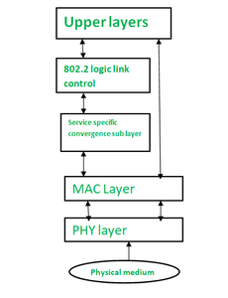

9.5 Working of IEEE 802.15.4

9.5.1 Physical Layer (PHY)
This layer handles wireless signal transmission.
Functions:
- Data transmission and reception
- Frequency selection
- Signal modulation
- Channel management
Frequency bands used:
- 2.4 GHz
- 915 MHz
- 868 MHz
Data rates:
- 250 kbps
- 40 kbps
- 20 kbps

9.5.2 MAC Layer
This layer controls communication between devices.
Functions:
- Device addressing
- Error detection
- Collision avoidance
- Data frame management
- Network access control
The MAC layer uses:
- CSMA/CA (Carrier Sense Multiple Access with Collision Avoidance)
This helps avoid data collisions.

9.6 Network Topologies in IEEE 802.15.4

i) Star Topology
- All devices communicate through a central coordinator.
- Easy to manage.
- Suitable for small networks.

ii) Peer-to-Peer Topology
- Devices communicate directly with each other.
- Suitable for large IoT systems.
- More flexible.

Diagram

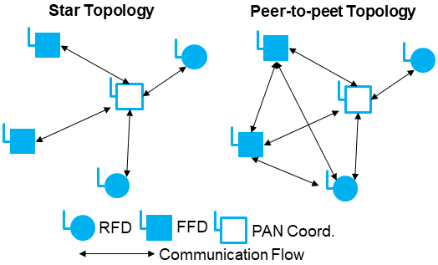

9.7 Types of Devices in IEEE 802.15.4

i) Full Function Device (FFD)
- Can communicate with all devices
- Acts as coordinator
- Supports routing
Examples: ZigBee coordinator

ii) Reduced Function Device (RFD)
- Simple devices with limited functions
- Low power consumption
- Cannot perform routing
Examples:
- Temperature sensors
- Motion detectors

9.8 Applications of IEEE 802.15.4
a) Wireless Sensor Networks (WSN): Used for sensor communication.
b) Smart Homes: Controls smart lights and appliances.
c) Healthcare Systems: Patient monitoring devices.
d) Industrial Automation: Machine monitoring systems.
e) Agriculture: Soil and irrigation monitoring.
f) Smart Cities: Street lighting and traffic management.

9.9 Advantages of IEEE 802.15.4
a) Very Low Power Usage: Suitable for battery-operated devices.
b) Simple Implementation: Easy to develop and maintain.
c) Low Cost Communication: Affordable for IoT applications.
d) Reliable Wireless Communication: Supports secure data transfer.
e) Supports IoT Technologies: Foundation for ZigBee and 6LoWPAN.
f) Scalable Network: Can connect many devices together.

9.10 Limitations of IEEE 802.15.4
a) Low data transfer speed
b) Short communication range
c) Not suitable for heavy multimedia data
d) Limited bandwidth

9.11 IEEE 802.15.4 and IoT
IEEE 802.15.4 is highly important for IoT because it provides:
- Low power wireless communication
- Efficient sensor connectivity
- Reliable short-range networking
Many IoT protocols such as:
- ZigBee
- 6LoWPAN
- Thread
are built using IEEE 802.15.4 standard.
Thus, it forms the basic communication technology for many smart IoT systems.

9.12 Comparison: IEEE 802.15.4 vs WiFi
Feature | IEEE 802.15.4 | WiFi
Power Consumption | Very Low | High
Data Rate | Low | High
Range | Short | Medium
Cost | Low | Higher
Usage | IoT Devices | Internet Access
Battery Life | Long | Short

9.13 Conclusion
IEEE 802.15.4 is a low-power wireless communication standard specially designed for IoT and sensor networks.
It provides:
- Reliable communication
- Low energy consumption
- Low-cost networking
It is widely used in ZigBee, WSN, smart homes, healthcare, industrial automation, and many modern IoT applications.

10. 6LoWPAN

10.1 Definition of 6LoWPAN
6LoWPAN stands for: IPv6 over Low Power Wireless Personal Area Networks
It is a communication technology that allows:
- Small IoT devices
- Sensors
- Embedded systems
to communicate using IPv6 over low-power wireless networks such as IEEE 802.15.4.
6LoWPAN acts as a bridge between:
- Internet Protocol (IPv6)
and
- Low-power IoT devices.
It helps IoT devices directly connect to the internet.

10.2 Features of 6LoWPAN
i) Supports IPv6: Allows IoT devices to use internet addressing.
ii) Low Power Consumption: Designed for battery-operated devices.
iii) Small Packet Size: Uses header compression to reduce packet size.
iv) Efficient Communication: Works efficiently in constrained networks.
v) Interoperability: Devices from different manufacturers can communicate.
vi) Supports Large Number of Devices: IPv6 provides huge address space.
vii) Mesh Networking Support: Devices can communicate through neighboring nodes.

10.3 Need of 6LoWPAN
Normal IPv6 packets are large and cannot efficiently work on low-power IoT devices.
Problems:
- Limited battery
- Small memory
- Low bandwidth
- Small frame size
6LoWPAN solves these problems by:
- Compressing IPv6 headers
- Reducing packet size
- Supporting lightweight communication
Thus, it makes IPv6 suitable for IoT devices.

10.4 Architecture of 6LoWPAN
6LoWPAN architecture consists of:
- IoT devices
- Adaptation layer
- IEEE 802.15.4 network
- Internet connection

10.5 Diagram of 6LoWPAN Architecture
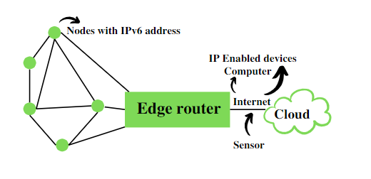

10.6 Working of 6LoWPAN

10.6.1 Data Collection
Sensors collect information from environment such as:
- Temperature
- Humidity
- Motion
- Light

10.6.2 IPv6 Packet Creation
The collected data is converted into IPv6 packets.

10.6.3 Header Compression
IPv6 headers are large.
6LoWPAN compresses headers to:
- Reduce packet size
- Save bandwidth
- Improve efficiency

10.6.4 Packet Transmission
Compressed packets are transmitted using:
- IEEE 802.15.4 wireless communication

10.6.5 Internet Communication
Packets reach:
- Gateway
- Router
- Cloud server
This allows IoT devices to communicate with internet services.

10.7 Components of 6LoWPAN
Component | Function
IPv6 | Internet addressing
Adaptation Layer | Header compression and fragmentation
IEEE 802.15.4 | Wireless communication
Gateway | Connects IoT network to internet
Sensor Nodes | Collect data

10.8 Functions of 6LoWPAN Adaptation Layer
The adaptation layer is the most important part of 6LoWPAN.
Functions:

i) Header Compression: Reduces IPv6 header size.

ii) Fragmentation: Breaks large packets into smaller packets.

iii) Reassembly: Combines fragmented packets again.

iv) Routing Support: Supports packet forwarding in mesh networks.

10.9 Advantages of 6LoWPAN
a) Direct Internet Connectivity: IoT devices can directly communicate with internet.
b) Low Power Consumption: Suitable for battery-based devices.
c) Efficient Data Transmission: Uses compressed packets.
d) Supports IPv6: Large address space for billions of devices.
e) Scalable Network: Can support many IoT devices.
f) Interoperability: Different systems can work together.

10.10 Applications of 6LoWPAN
a) Smart Home Systems: Smart lights and appliances.
b) Healthcare Monitoring: Wearable health sensors.
c) Industrial IoT: Machine monitoring systems.
d) Agriculture: Smart irrigation and soil monitoring.
e) Smart Cities: Traffic and street light management.
f) Environmental Monitoring: Weather and pollution monitoring.

10.11 6LoWPAN vs IPv4
Feature | 6LoWPAN | IPv4
Address Type | IPv6 | IPv4
Power Consumption | Low | Higher
Packet Size | Compressed | Larger
IoT Support | Excellent | Limited
Address Space | Very Large | Limited
Network Type | Low-power IoT | Traditional Internet

10.12 6LoWPAN vs IPv6
Feature | 6LoWPAN | Normal IPv6
Header Size | Compressed | Large
Power Requirement | Low | Higher
Suitable for IoT | Yes | Limited
Communication Network | IEEE 802.15.4 | Traditional Networks
Packet Handling | Lightweight | Heavy

10.13 Role of 6LoWPAN in IoT
6LoWPAN plays a major role in IoT because:
- It enables internet connectivity for tiny devices.
- It supports low-power communication.
- It allows efficient wireless sensor networking.
- It helps connect billions of smart devices.
It is widely used in:
- Wireless Sensor Networks
- Smart homes
- Smart healthcare
- Industrial automation

10.14 Limitations of 6LoWPAN
a) Limited communication range
b) Low data rate
c) Security challenges
d) Not suitable for large multimedia data

10.15 Conclusion
6LoWPAN is an important IoT communication technology that enables IPv6 communication over low-power wireless networks.
It provides:
- Low power communication
- Efficient packet transmission
- Internet connectivity for IoT devices
6LoWPAN is widely used in smart homes, healthcare, agriculture, industrial automation, and Wireless Sensor Networks.

11. NFC (Near Field Communication)

11.1 Definition of NFC
NFC stands for Near Field Communication.
It is a short-range wireless communication technology that allows two electronic devices to exchange data when they are brought very close to each other, usually within 4 cm.
NFC is based on:
- RFID technology
- Electromagnetic radio fields
It is widely used in:
- Mobile payments
- Smart cards
- Access systems
- IoT devices
Examples:
- Google Pay
- Phone tap-to-pay systems
- Metro smart cards
- Smart door locks

11.2 Features of NFC
i) Short Range Communication: Works only within a few centimeters.
ii) Fast Connection Setup: Devices connect instantly.
iii) Secure Communication: Short range reduces unauthorized access.
iv) Low Power Consumption: Consumes very little energy.
v) Easy to Use: Requires simple tap or touch.
vi) Two-Way Communication: Both devices can send and receive data.
vii) Compatibility with RFID: Can work with RFID systems.

11.3 Working Principle of NFC
NFC works using:
- Electromagnetic induction
- Radio frequency communication
When two NFC-enabled devices come close:
- A wireless connection is created.
- Data is exchanged automatically.
- Communication occurs at high speed for short distance.
One device creates a magnetic field and the other device receives the signal.

11.4 Diagram of NFC Communication
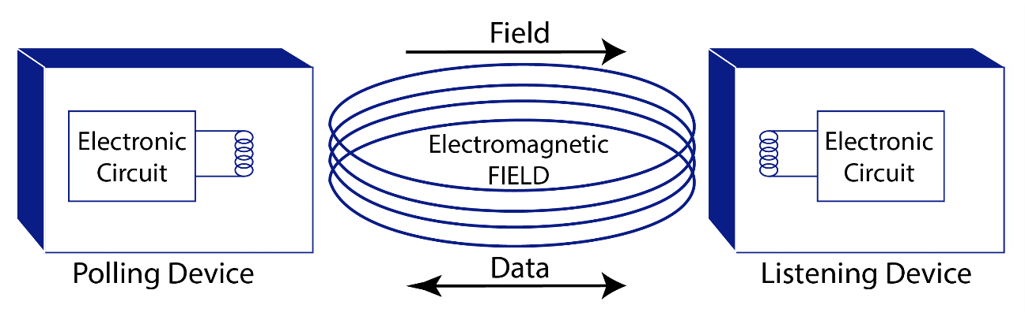

11.5 Modes of NFC Operation
NFC mainly works in three modes.

11.5.1 Peer-to-Peer Mode
- Two devices communicate directly.
- Both devices can exchange data.
Examples:
- File sharing between phones
- Contact sharing

Diagram

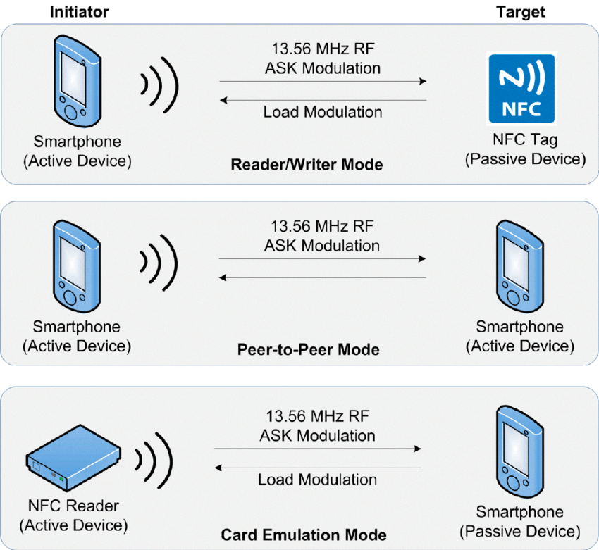

11.5.2 Reader/Writer Mode
- NFC device reads information from NFC tags.
Examples:
- Reading smart posters
- Scanning NFC cards

Diagram



11.5.3 Card Emulation Mode
- Smartphone behaves like a smart card.

Examples:
- Mobile payment systems
- Metro ticket systems

Diagram


11.6 Components of NFC System
Component | Function
NFC Device | Sends/receives data
NFC Tag | Stores information
Antenna | Wireless signal transmission
Reader | Reads NFC data
Controller Chip | Controls communication

11.7 Working of NFC

Step 1: Device Detection
Two NFC-enabled devices come close to each other.

Step 2: Connection Establishment
Electromagnetic field creates communication link.

Step 3: Data Exchange
Data is transmitted wirelessly.

Step 4: Action Execution
Required task is completed.
Examples:
- Payment successful
- Door unlocked
- Data transferred

11.8 Advantages of NFC
a) Fast Communication: Connection setup is very quick.
b) Easy to Use: Simple tap-based operation.
c) Secure Communication: Very short range improves security.
d) Low Power Requirement: Suitable for mobile devices.
e) Automatic Connectivity: No manual pairing required.
f) Compact Technology: Can be integrated into small devices.

11.9 Limitations of NFC
a) Very short communication range
b) Low data transfer speed
c) Not suitable for large data transfer
d) Limited operating distance

11.10 Applications of NFC

a) Mobile Payments
Used in Google Pay, PhonePe, Tap-to-pay systems.

b) Smart Access Systems
Used in Smart door locks, Office entry systems.

c) Transportation
Used in Metro smart cards, Bus ticket systems.

d) Healthcare
Used in Patient identification, Medical record access.

e) IoT and Smart Homes
Used for Device pairing, Smart appliance control.

f) Data Sharing
Used for Contact sharing, Small file transfer.

11.11 NFC vs Bluetooth
Feature | NFC | Bluetooth
Range | Very Short | Longer
Setup Time | Instant | Slower
Power Consumption | Very Low | Moderate
Data Speed | Low | Higher
Security | More Secure | Less Secure
Usage | Payments, Tags | Audio, File Transfer

11.12 NFC vs RFID
Feature | NFC | RFID
Communication Type | Two-way | Mostly one-way
Range | Very Short | Longer
Device Interaction | Active communication | Mainly identification
Speed | Faster setup | Moderate
Applications | Payments, Phones | Tracking, Inventory

11.13 Role of NFC in IoT
NFC is important in IoT because it:
- Enables quick device pairing
- Supports secure authentication
- Helps smart devices communicate easily
- Simplifies automation systems
Examples:
- Smart home device setup
- IoT access control
- Smart healthcare systems

11.14 Conclusion
NFC is a short-range wireless communication technology used for secure and fast data exchange between nearby devices.
It provides:
- Easy connectivity
- Low power communication
- Secure wireless interaction
NFC is widely used in mobile payments, smart cards, healthcare, transportation, smart homes, and IoT applications.

12. MQTT

12.1 Definition of MQTT
MQTT stands for: Message Queuing Telemetry Transport
It is a lightweight messaging protocol used for communication between IoT devices over the internet.
MQTT is specially designed for:
- Low bandwidth networks
- Low power devices
- Unstable internet connections
It follows the Publish-Subscribe communication model.
MQTT is widely used in:
- Smart homes
- Industrial IoT
- Healthcare systems
- Sensor networks
Examples:
- Smart temperature monitoring
- Home automation systems
- Smart agriculture

12.2 Features of MQTT
i) Lightweight Protocol: Uses very small packet size.
ii) Low Power Consumption: Suitable for battery-operated IoT devices.
iii) Fast Communication: Provides quick message transfer.
iv) Reliable Messaging: Supports Quality of Service (QoS).
v) Publish-Subscribe Model: Devices communicate indirectly through broker.
vi) Works on Low Bandwidth: Efficient for weak internet connections.
vii) Scalable: Can connect thousands of devices.

12.3 MQTT Architecture
MQTT architecture mainly contains:
- Publisher
- Broker
- Subscriber
- Topic

12.4 Diagram of MQTT Architecture

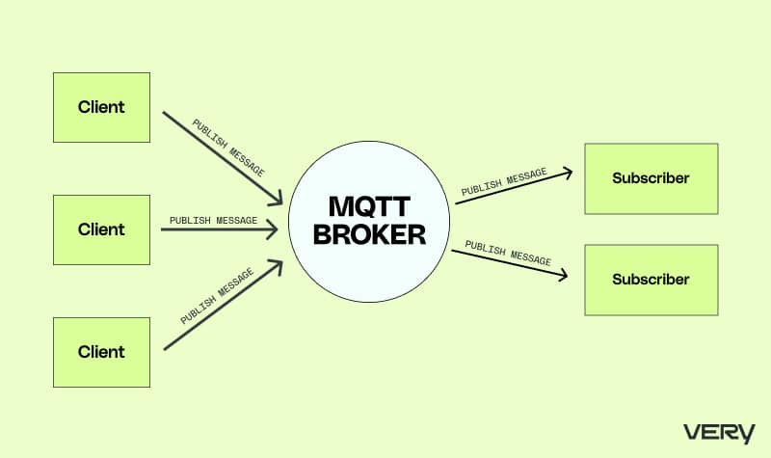

12.5 Components of MQTT
Component | Function
Publisher | Sends data/messages
Broker | Receives and distributes messages
Subscriber | Receives messages
Topic | Communication channel
Client | Any device using MQTT

12.6 Working of MQTT
MQTT works using the Publish-Subscribe method.

Step 1: Publisher Sends Data
A sensor or device sends data to a topic.
Example: Temperature sensor sends room temperature.

Step 2: Broker Receives Message
The broker acts as a central server.
Functions:
- Receives messages
- Manages clients
- Sends messages to subscribers
Popular MQTT Brokers:
- Mosquitto
- HiveMQ

Step 3: Subscriber Receives Data
Devices subscribed to the topic receive messages automatically.
Example: Mobile app receives temperature update.

12.7 MQTT Topics
A topic is a communication channel used for message exchange.
Example Topics:
- home/temperature
- smartlight/status
- agriculture/moisture
Publishers send data to topics, and subscribers receive data from topics.

12.8 MQTT Quality of Service (QoS)
MQTT provides reliable communication using QoS levels.
QoS Level | Description
QoS 0 | Message delivered at most once
QoS 1 | Message delivered at least once
QoS 2 | Message delivered exactly once

12.9 MQTT Packet Structure
MQTT packets contain:
- Header
- Topic name
- Payload (actual data)
Example Payload: Temperature = 30°C

12.10 Advantages of MQTT
a) Low Bandwidth Usage: Small packet size reduces bandwidth usage.
b) Low Power Consumption: Ideal for IoT sensors and devices.
c) Reliable Communication: QoS ensures message delivery.
d) Fast Data Transmission: Quick communication between devices.
e) Easy Implementation: Simple protocol structure.
f) Supports Large IoT Networks: Can connect many devices together.

12.11 Limitations of MQTT
a) Requires broker server
b) Less secure without encryption
c) Not suitable for large multimedia data
d) Central broker failure can affect communication

12.12 Applications of MQTT

a) Smart Home
Used for Smart lights, Smart fans, Security systems.

b) Healthcare
Used for Patient monitoring, Wearable devices.

c) Industrial IoT
Used for Machine monitoring, Factory automation.

d) Smart Agriculture
Used for Soil monitoring, Smart irrigation systems.

e) Transportation
Used in Vehicle tracking, Smart traffic systems.

f) Environmental Monitoring
Used for Pollution monitoring, Weather systems.

12.13 MQTT Communication Flow
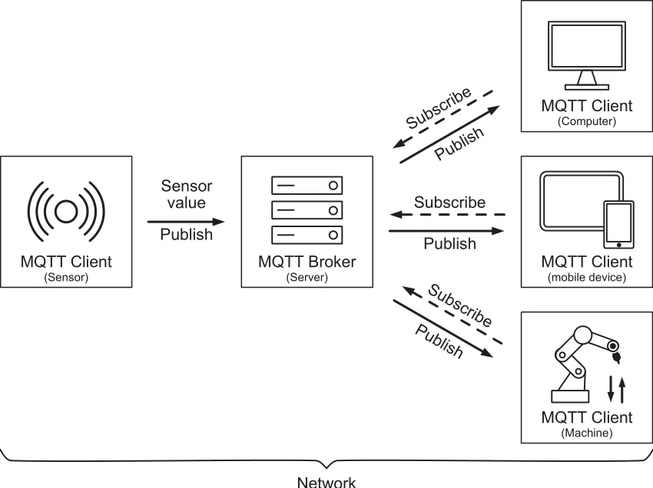
Example:
- Sensor publishes temperature data.
- Broker receives data.
- Mobile app subscribed to topic receives data instantly.

12.14 MQTT vs HTTP
Feature | MQTT | HTTP
Communication Model | Publish-Subscribe | Request-Response
Bandwidth Usage | Low | Higher
Power Consumption | Low | Higher
Speed | Faster | Slower
Suitable for IoT | Yes | Limited
Connection Type | Persistent | Temporary

12.15 MQTT vs CoAP
Feature | MQTT | CoAP
Communication Type | Publish-Subscribe | Request-Response
Protocol Base | TCP | UDP
Reliability | High | Moderate
Complexity | Simple | Very Simple
Usage | Messaging | Lightweight device communication

12.16 Role of MQTT in IoT
MQTT is one of the most important IoT communication protocols because:
- It supports low-power devices.
- It works efficiently on slow networks.
- It provides reliable communication.
- It supports real-time messaging.
It is widely used in:
- Smart homes
- Smart cities
- Industrial automation
- Healthcare IoT

12.17 Conclusion
MQTT is a lightweight and efficient messaging protocol specially designed for IoT communication. It uses the Publish-Subscribe model for fast and reliable message exchange between devices.
Because of:
- Low power consumption
- Small packet size
- Reliable communication
MQTT is widely used in smart homes, healthcare, industrial IoT, agriculture, and many modern IoT applications.

13. CoAP

13.1 Definition of CoAP
CoAP stands for: Constrained Application Protocol
It is a lightweight web transfer protocol specially designed for:
- IoT devices
- Low power systems
- Constrained networks
CoAP enables communication between IoT devices using a simple request-response model similar to HTTP.
It is mainly used where:
- Devices have limited memory
- Low bandwidth is available
- Fast communication is required
CoAP works on UDP (User Datagram Protocol).
Examples:
- Smart sensors
- Smart home devices
- Wireless sensor networks

13.2 Features of CoAP
i) Lightweight Protocol: Uses small packet size.
ii) Low Power Consumption: Suitable for battery-operated devices.
iii) Fast Communication: Works on UDP for faster transmission.
iv) Simple Request-Response Model: Similar to HTTP communication.
v) Supports Multicast Communication: Can send messages to multiple devices.
vi) Easy Integration with Web: Can interact with HTTP systems.
vii) Reliable Communication: Uses message acknowledgment system.

13.3 CoAP Architecture
CoAP architecture mainly contains:
- Client
- Server
- Resources
- UDP communication

13.4 Diagram of CoAP Architecture
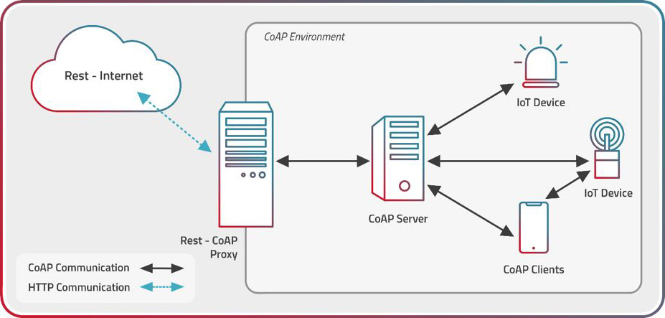

13.5 Working of CoAP
CoAP follows a Request-Response communication model.

Step 1: Client Sends Request
The client requests information from server.
Example: Sensor asks for temperature data.
Request methods:
- GET
- POST
- PUT
- DELETE

Step 2: Server Processes Request
The server receives and processes the request.

Step 3: Server Sends Response
The requested information is sent back to client.
Example: Temperature = 28°C

13.6 CoAP Methods
Method | Function
GET | Retrieve data
POST | Send new data
PUT | Update existing data
DELETE | Remove data

13.7 CoAP Message Types
CoAP uses four message types.

i) Confirmable (CON)
- Requires acknowledgment.
- Reliable communication.
Example: Important sensor data.

ii) Non-Confirmable (NON)
- No acknowledgment required.
- Faster communication.
Example: Regular status updates.

iii) Acknowledgment (ACK)
- Sent as response to confirmable message.

iv) Reset (RST)
- Indicates message cannot be processed.

13.8 Diagram of CoAP Message Flow

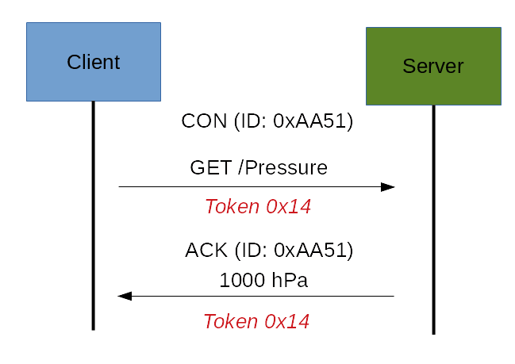

13.9 Components of CoAP
Component | Function
Client | Sends requests
Server | Provides services
Resource | Data/service provided
UDP | Transport protocol
Message Layer | Handles message transfer

13.10 Advantages of CoAP
a) Low Overhead: Uses very small packet size.
b) Low Power Usage: Suitable for constrained IoT devices.
c) Fast Communication: UDP provides quick transmission.
d) Simple Protocol: Easy to implement.
e) Supports Web Integration: Can communicate with HTTP systems.
f) Supports Multicast: Can communicate with multiple devices simultaneously.

13.11 Limitations of CoAP
a) Less secure without additional security layers
b) UDP may cause packet loss
c) Limited reliability compared to TCP
d) Not suitable for large data transfer

13.12 Applications of CoAP

a) Smart Homes
Used for Smart lights, Smart appliances.

b) Healthcare
Used in Wearable health devices, Patient monitoring systems.

c) Smart Agriculture
Used for Soil sensors, Irrigation control.

d) Industrial IoT
Used for Machine monitoring, Industrial sensors.

e) Environmental Monitoring
Used for Weather monitoring, Pollution monitoring.

f) Wireless Sensor Networks
Used for communication between sensor nodes.

13.13 CoAP Request-Response Model
The CoAP Request-Response model is similar to HTTP.

Process:
- Client sends request.
- Server processes request.
- Server returns response.
Example:
GET: Temperature
Response: 30°C
This model is efficient for constrained IoT networks.

13.14 CoAP vs HTTP
Feature | CoAP | HTTP
Transport Protocol | UDP | TCP
Packet Size | Small | Larger
Speed | Faster | Slower
Power Consumption | Low | Higher
Suitable for IoT | Yes | Limited
Communication Type | Lightweight | Heavy

13.15 CoAP vs MQTT
Feature | CoAP | MQTT
Communication Model | Request-Response | Publish-Subscribe
Transport Layer | UDP | TCP
Speed | Faster | Reliable
Power Usage | Very Low | Low
Usage | Device communication | Messaging systems

13.16 Role of CoAP in IoT
CoAP is important in IoT because:
- It supports lightweight communication.
- It works efficiently in constrained networks.
- It reduces bandwidth and power usage.
- It enables fast communication between IoT devices.
It is widely used in:
- Sensor networks
- Smart homes
- Industrial IoT
- Smart healthcare

13.17 Conclusion
CoAP is a lightweight communication protocol specially designed for IoT and constrained devices.
It uses:
- UDP communication
- Request-response model
- Small packet size
Because of:
- Low power consumption
- Fast communication
- Lightweight structure
CoAP is widely used in smart homes, wireless sensor networks, healthcare, agriculture, and industrial IoT systems.

14. AMQP

14.1 Definition of AMQP
AMQP stands for Advanced Message Queuing Protocol.
It is an application layer messaging protocol used for reliable communication between devices, servers, and applications in IoT systems.
AMQP allows devices to:
- Send messages
- Receive messages
- Queue data safely
- Ensure secure and reliable communication
It is mainly used in:
- Cloud-based IoT systems
- Enterprise applications
- Banking systems
- Real-time communication systems
AMQP works on a message-oriented middleware concept where messages are stored in queues before delivery.

14.2 Features of AMQP

i) Reliable Communication: Messages are delivered safely without loss.

ii) Message Queuing: Messages are stored in queues until received.

iii) Security: Supports authentication and encryption.

iv) Interoperability: Different devices and platforms can communicate easily.

v) Asynchronous Communication: Sender and receiver do not need to communicate at the same time.

vi) Scalability: Can support large numbers of IoT devices.

vii) Flexibility: Supports routing, queuing, and message filtering.

14.3 Components of AMQP
Component | Function
Producer | Sends messages
Consumer | Receives messages
Exchange | Routes messages
Queue | Stores messages
Broker | Manages message communication
Binding | Connects exchange with queues

14.4 Diagram of AMQP Architecture

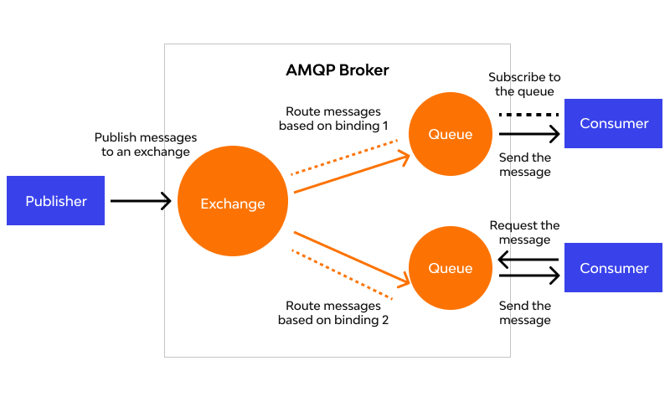

14.5 Working of AMQP

Step 1: Producer Sends Message
The sender device or application creates a message and sends it to the exchange.

Step 2: Exchange Receives Message
The exchange checks routing rules and decides where the message should go.

Step 3: Queue Stores Message
The message is stored safely in a queue.

Step 4: Consumer Receives Message
The receiver device reads the message from the queue.

Step 5: Acknowledgement
The consumer sends acknowledgement after successful receipt.

14.6 Types of Exchanges in AMQP

i) Direct Exchange: Routes messages using exact routing key.

ii) Fanout Exchange: Sends messages to all queues.

iii) Topic Exchange: Routes messages based on patterns or topics.

iv) Headers Exchange: Uses message headers for routing.

14.7 AMQP Frame Types
AMQP communication uses frames for transferring data.
Main frame types are:
Frame Type | Function
Method Frame | Carries commands
Header Frame | Contains message properties
Body Frame | Contains actual message data
Heartbeat Frame | Maintains connection

14.8 Advantages of AMQP

a) Reliable Messaging: Ensures guaranteed delivery.

b) Secure Communication: Supports SSL/TLS security.

c) Queue Management: Messages are not lost during failures.

d) Platform Independent: Works on different systems.

e) Scalable: Suitable for large IoT networks.

f) Supports Asynchronous Communication: Improves system performance.

14.9 Disadvantages of AMQP

a) Complex Protocol: More complicated than MQTT.

b) Higher Resource Usage: Consumes more memory and bandwidth.

c) Heavy for Small Devices:Not suitable for low-power constrained devices.

14.10 Applications of AMQP

a) IoT Cloud Platforms: Used for cloud communication.

b) Banking Systems: Secure transaction messaging.

c) Enterprise Messaging: Communication between applications.

d) Industrial Automation: Machine-to-machine communication.

e) Real-Time Monitoring: Sensor data transfer and monitoring.

14.11 AMQP vs MQTT
Feature | AMQP | MQTT
Full Form | Advanced Message Queuing Protocol | Message Queuing Telemetry Transport
Complexity | More complex | Lightweight
Reliability | Very high | Moderate
Queue Support | Yes | Limited
Security | Strong | Moderate
Resource Usage | High | Low
Best Use | Enterprise systems | Small IoT devices

14.12 Conclusion
AMQP is a reliable and secure messaging protocol used in IoT and enterprise applications for communication between devices and servers.
It provides message queuing, routing, and guaranteed delivery, making it suitable for cloud systems, industrial automation, and large-scale IoT applications.

15. SMQTT

15.1 Definition of SMQTT
SMQTT stands for Secure Message Queuing Telemetry Transport.
It is the secure version of the MQTT protocol used in IoT systems for safe message communication between devices.
SMQTT provides:
- Secure data transfer
- Authentication
- Encryption
- Protection from unauthorized access
It is specially designed for:
- Smart devices
- Wireless sensor networks
- Low-power IoT systems
SMQTT improves the security weaknesses present in normal MQTT communication.

15.2 Need of SMQTT in IoT
Normal MQTT is lightweight but has limited built-in security.
IoT devices exchange sensitive information such as:
- Personal data
- Sensor readings
- Industrial information
- Smart home controls
Without security, attackers can:
- Steal data
- Modify messages
- Access devices illegally
Therefore, SMQTT is used for secure communication.

15.3 Features of SMQTT

i) Secure Communication: Protects data during transmission.

ii) Lightweight Protocol: Suitable for low-power IoT devices.

iii) Authentication: Verifies sender and receiver identity.

iv) Data Encryption: Converts plain data into secure encrypted form.

v) Confidentiality: Prevents unauthorized access to data.

vi) Integrity: Ensures messages are not modified.

vii) Low Bandwidth Usage: Consumes less network resources.

15.4 Architecture of SMQTT
Main components of SMQTT are:
Component | Function
Publisher | Sends messages
Broker | Manages message delivery
Subscriber | Receives messages
Encryption Module | Secures data
Authentication System | Verifies users

15.5 Diagram of SMQTT
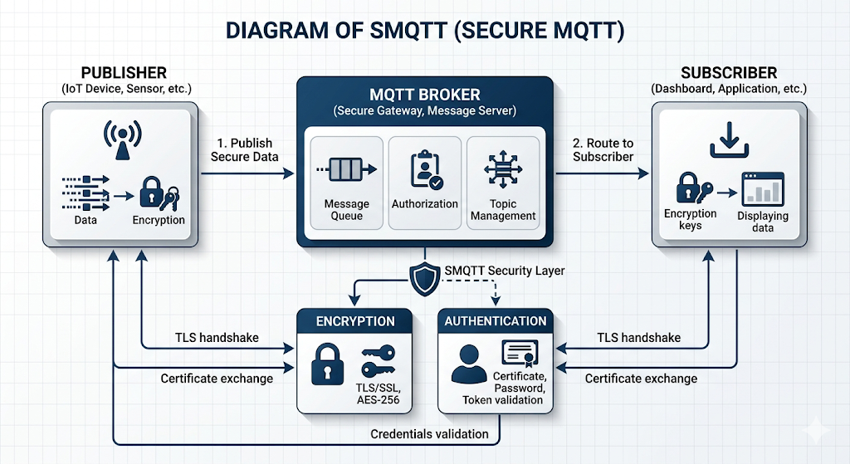

15.6 Working of SMQTT

Step 1: Publisher Creates Message
The sender device creates sensor or application data.

Step 2: Encryption of Message
The message is encrypted using security algorithms.

Step 3: Message Sent to Broker
Encrypted data is transmitted to MQTT broker.

Step 4: Authentication
Broker verifies authorized users and devices.

Step 5: Message Forwarding
Broker forwards message to subscribers.

Step 6: Decryption
Subscriber decrypts the received message.

15.7 Security Mechanisms Used in SMQTT

i) Encryption: Protects message content from attackers.

ii) Authentication: Ensures only valid users can communicate.

iii) Access Control: Restricts unauthorized device access.

iv) Digital Signature: Verifies originality of message.

v) Secure Key Exchange: Safely shares encryption keys.

15.8 Advantages of SMQTT

a) Improved Security: Provides secure communication in IoT.

b) Lightweight: Suitable for constrained devices.

c) Low Power Consumption: Consumes less battery power.

d) Reliable Communication: Ensures safe message delivery.

e) Easy Integration: Can be integrated with MQTT systems.

f) Better Privacy: Protects confidential user data.

15.9 Disadvantages of SMQTT

a) Extra Processing: Encryption increases computation.

b) Key Management Complexity: Managing encryption keys can be difficult.

c) Slight Communication Delay: Security operations may increase latency.

15.10 Applications of SMQTT

a) Smart Home Systems: Secure communication between smart appliances.

b) Healthcare Monitoring: Protects patient medical data.

c) Industrial IoT: Secure machine communication.

d) Smart Cities: Secure traffic and surveillance systems.

e) Banking and Financial Systems: Secure IoT payment systems.

f) Military Applications: Secure sensor communication networks.

15.11 Difference Between MQTT and SMQTT
Feature | MQTT | SMQTT
Security | Basic | High security
Encryption | Limited | Strong encryption
Authentication | Basic | Advanced
Data Protection | Less secure | More secure
Complexity | Simple | Slightly complex
Usage | General IoT | Secure IoT applications

15.12 Conclusion
SMQTT is a secure version of MQTT that provides safe communication for IoT systems using encryption and authentication techniques.
It helps protect sensitive data, prevents unauthorized access, and ensures reliable communication in smart homes, healthcare, industries, and other IoT applications.

16. XMPP

16.1 Definition of XMPP
XMPP stands for Extensible Messaging and Presence Protocol.
It is an XML-based communication protocol used for:
- Real-time messaging
- Device communication
- Presence information exchange
XMPP was originally developed for instant messaging applications but is now widely used in IoT systems for communication between devices, servers, and users.
It supports:
- Real-time data exchange
- Device-to-device communication
- Scalable communication networks

16.2 Features of XMPP

i) Real-Time Communication: Provides instant message transfer.

ii) Open Standard Protocol: Anyone can use and implement it.

iii) Extensible: New features can be added easily.

iv) Secure Communication: Supports encryption and authentication.

v) Distributed Architecture: No single central server is required.

vi) Scalability: Can support large IoT networks.

vii) Interoperability: Different platforms and devices can communicate.

16.3 Components of XMPP
Component | Function
Client | Sends and receives messages
Server | Manages communication
XML Stream | Transfers data
Presence Service | Shows device/user availability
Gateway | Connects different networks

16.4 Diagram of XMPP Architecture
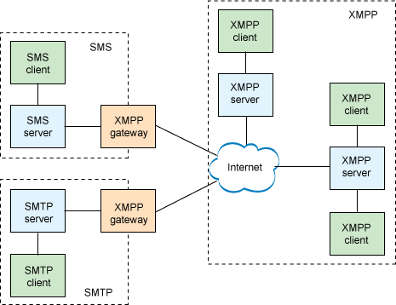

16.5 Working of XMPP

Step 1: Client Connects to Server
IoT devices or users connect to XMPP server.

Step 2: Authentication
Server verifies the identity of devices.

Step 3: XML Stream Creation
Communication starts using XML streams.

Step 4: Message Exchange
Devices send and receive messages in real time.

Step 5: Presence Information
Server updates device availability status.

Step 6: Secure Communication
Encryption ensures secure data transfer.

16.6 XMPP Architecture Layers

i) Transport Layer: Handles data transfer using TCP/IP.

ii) XML Streaming Layer: Manages XML message streams.

iii) XMPP Core Layer: Controls messaging and presence information.

iv) Application Layer: Provides IoT services and applications.

16.7 Advantages of XMPP

a) Real-Time Messaging: Provides fast communication.

b) High Scalability: Supports large networks.

c) Secure Communication: Supports TLS and authentication.

d) Open Source: Free and flexible protocol.

e) Supports Presence Information: Shows online/offline device status.

f) Flexible Architecture: Easy to expand and customize.

16.8 Disadvantages of XMPP

a) More Bandwidth Usage: XML messages are larger in size.

b) Complex Protocol: More complicated than MQTT.

c) Higher Power Consumption: Consumes more resources in small devices.

16.9 Applications of XMPP

a) Instant Messaging: Chat applications and messaging systems.

b) Smart Home Systems: Communication between smart devices.

c) IoT Device Management: Monitoring and controlling IoT devices.

d) Online Gaming: Real-time multiplayer communication.

e) Healthcare Systems: Patient monitoring communication.

f) Industrial Automation: Machine communication and monitoring.

16.10 XMPP vs MQTT
Feature | XMPP | MQTT
Protocol Type | XML-based | Lightweight messaging
Communication | Real-time messaging | Publish/Subscribe
Data Size | Larger | Smaller
Complexity | More complex | Simple
Bandwidth Usage | High | Low
Best Use | Messaging systems | IoT sensor networks

16.11 XMPP vs AMQP
Feature | XMPP | AMQP
Communication | Real-time chat/message | Message queuing
Data Format | XML | Binary frames
Complexity | Moderate | High
Scalability | Good | Very high
Main Usage | Messaging and presence | Enterprise messaging

16.12 Conclusion
XMPP is a real-time communication protocol used in IoT systems for messaging, device communication, and presence management.
Its secure and extensible architecture makes it suitable for smart homes, healthcare systems, industrial automation, and real-time communication applications.

17. IoT Security

17.1 Definition of IoT Security
IoT Security refers to the protection of IoT devices, networks, software, and data from unauthorized access, cyber attacks, and data theft.
IoT systems contain:
- Smart devices
- Sensors
- Networks
- Cloud platforms
- Applications
Since these devices are connected through the internet, they are vulnerable to various security threats.
IoT security ensures:
- Safe communication
- Data privacy
- Device protection
- Reliable operation

17.2 Need of IoT Security
Security is important in IoT because IoT devices handle sensitive and real-time information.
Without security:
- Hackers can steal data
- Devices can be controlled illegally
- Systems may stop working
- User privacy may be violated
Examples:
- Smart home hacking
- Medical data theft
- Industrial system attacks
- Smart vehicle hacking

17.3 Objectives of IoT Security

i) Confidentiality: Data should only be accessed by authorized users.

ii) Integrity: Data should not be modified illegally.

iii) Authentication: Only valid users and devices can access the system.

iv) Availability: Services should remain available continuously.

v) Privacy: Personal information must remain protected.

vi) Non-Repudiation: Users cannot deny their actions after communication.

17.4 Diagram of IoT Security
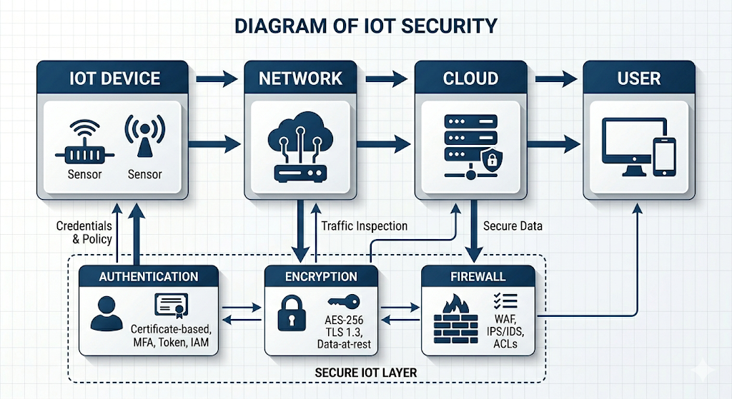

17.5 Security Layers in IoT

17.5.1 Device Security
Protects sensors, actuators, and hardware devices.
Methods:
- Secure boot
- Password protection
- Device authentication

17.5.2 Network Security
Protects communication networks.
Methods:
- Firewalls
- VPN
- Secure protocols
- Encryption

17.5.3 Cloud Security
Protects cloud storage and servers.
Methods:
- Data encryption
- Secure APIs
- Access control

17.5.4 Application Security
Protects IoT software and applications.
Methods:
- Authentication
- Secure coding
- Malware protection

17.6 Common Attacks in IoT Systems

i) Malware Attack: Malicious software damages devices or steals data.

ii) Denial of Service (DoS) Attack: Attackers overload the system and stop services.

iii) Man-in-the-Middle Attack: Attackers secretly intercept communication.

iv) Password Attack: Weak passwords are hacked easily.

v) Data Theft: Sensitive information is stolen.

vi) Device Hijacking: Attackers gain control of IoT devices.

vii) Phishing Attack: Fake messages trick users into revealing data.

17.7 Vulnerabilities in IoT
Vulnerability | Description
Weak Passwords | Easy to hack
Lack of Encryption | Data can be intercepted
Poor Software Updates | Security bugs remain
Insecure APIs | Unauthorized access possible
Low Processing Power | Difficult to implement strong security

17.8 Security Mechanisms in IoT

i) Encryption: Converts data into secure coded form.

ii) Authentication: Verifies user and device identity.

iii) Access Control: Restricts unauthorized users.

iv) Firewall: Blocks suspicious traffic.

v) Intrusion Detection System (IDS): Detects abnormal activities.

vi) Secure Communication Protocols: Protocols like HTTPS, TLS, SMQTT provide secure communication.

17.9 Advantages of IoT Security

a) Protects Sensitive Data: Keeps user information safe.

b) Prevents Unauthorized Access: Only valid users can access systems.

c) Improves Reliability: Systems work safely without interruptions.

d) Maintains Privacy: Protects personal and business data.

e) Reduces Cyber Attacks: Helps detect and stop attacks.

17.10 Challenges of IoT Security

a) Large Number of Devices: Difficult to secure all devices.

b) Limited Device Resources: Low memory and power limit security implementation.

c) Heterogeneous Devices: Different devices use different technologies.

d) Frequent Connectivity: Continuous internet connection increases risks.

e) Lack of Standardization: No universal security standards.

17.11 Applications of IoT Security

a) Smart Homes: Protects smart appliances and cameras.

b) Healthcare: Protects patient medical records.

c) Smart Cities: Secures traffic and surveillance systems.

d) Industrial IoT: Protects factory automation systems.

e) Banking Systems: Secures online payment systems.

f) Transportation: Protects connected vehicles.

17.12 IoT Security vs Traditional Security
Feature | IoT Security | Traditional Security
Devices | Smart connected devices | Computers and servers
Resource Availability | Limited | High
Connectivity | Continuous internet | Limited networking
Security Complexity | High | Moderate
Scalability | Very large networks | Smaller networks

17.13 Conclusion
IoT security is essential for protecting smart devices, communication networks, and sensitive information from cyber attacks and unauthorized access.
It uses authentication, encryption, firewalls, and secure protocols to ensure safe communication and reliable operation of IoT systems in healthcare, industries, smart homes, and smart cities.

18. Data Analytics in IoT

18.1 Definition of Data Analytics in IoT
Data Analytics in IoT refers to the process of collecting, processing, analyzing, and interpreting data generated by IoT devices to obtain useful information and make intelligent decisions.
IoT devices continuously generate huge amounts of data through:
- Sensors
- Smart devices
- Machines
- Wearable devices
Data analytics helps convert raw data into meaningful insights.

18.2 Need of Data Analytics in IoT
IoT systems generate large volumes of real-time data.
Without analytics:
- Data becomes difficult to manage
- Important information may be missed
- Decision making becomes slow
Data analytics helps to:
- Detect patterns
- Predict future events
- Improve efficiency
- Automate decision making
Example: A smart farming system analyzes soil moisture data to automatically control irrigation.

18.3 Types of Data Analytics in IoT

i) Descriptive Analytics
Analyzes past data to understand what happened.
Example: Daily temperature reports.

ii) Diagnostic Analytics
Finds the reason behind a problem.
Example: Finding why a machine failed.

iii) Predictive Analytics
Predicts future events using historical data.
Example: Weather prediction and predictive maintenance.

iv) Prescriptive Analytics
Suggests actions to solve problems.
Example: Automatic traffic control suggestions.

18.4 Diagram of Data Analytics in IoT
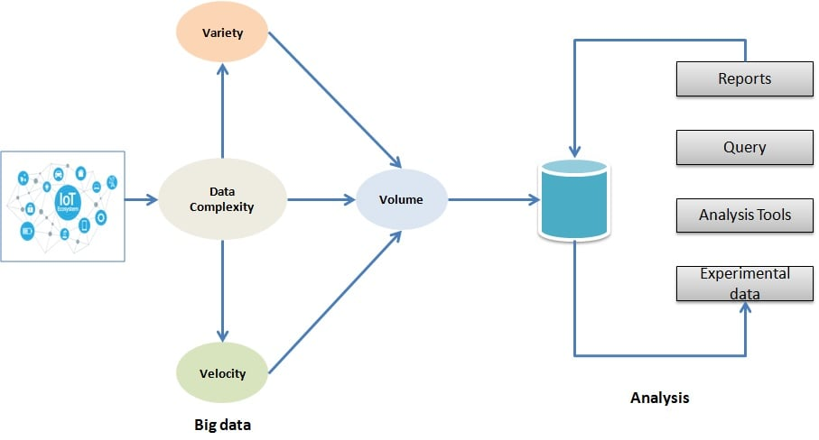

18.5 Working of Data Analytics in IoT

Step 1: Data Collection
Sensors and IoT devices collect data from the environment.
Examples:
- Temperature
- Humidity
- Motion
- Location

Step 2: Data Transmission
Collected data is transmitted through networks such as:
- WiFi
- Bluetooth
- ZigBee
- 6LoWPAN

Step 3: Data Storage
Data is stored in:
- Cloud servers
- Databases
- Data centers

Step 4: Data Processing
Raw data is cleaned and processed.
Techniques used:
- Filtering
- Aggregation
- Classification

Step 5: Data Analysis
Analytics tools analyze patterns and trends.
Technologies:
- Artificial Intelligence (AI)
- Machine Learning (ML)
- Big Data tools

Step 6: Decision Making
Useful information is used for:
- Automation
- Alerts
- Predictions
- Smart control systems

18.6 Components of IoT Data Analytics
Component | Function
Sensors | Generate data
Communication Network | Transfers data
Cloud Platform | Stores data
Analytics Engine | Analyzes data
User Interface | Displays results

18.7 Advantages of Data Analytics in IoT

a) Better Decision Making: Provides intelligent insights from data.

b) Real-Time Monitoring: Continuously monitors systems.

c) Predictive Maintenance: Detects faults before failures occur.

d) Automation: Reduces manual intervention.

e) Improved Efficiency: Optimizes system performance.

f) Cost Reduction: Reduces operational and maintenance costs.

18.8 Challenges of Data Analytics in IoT

a) Large Data Volume: Huge amounts of data are generated.

b) Data Security: Sensitive data must be protected.

c) High Storage Requirement: Large storage systems are needed.

d) Real-Time Processing: Fast processing is required.

e) Data Quality Issues: Incorrect or incomplete data affects analysis.

18.9 Applications of Data Analytics in IoT

a) Smart Healthcare: Patient monitoring and disease prediction.

b) Smart Agriculture: Soil analysis and irrigation control.

c) Smart Cities: Traffic monitoring and energy management.

d) Industrial IoT: Machine monitoring and predictive maintenance.

e) Smart Homes: Energy optimization and security systems.

f) Transportation: Vehicle tracking and route optimization.

18.10 IoT Analytics vs Traditional Data Analytics
Feature | IoT Analytics | Traditional Analytics
Data Source | IoT devices and sensors | Databases and records
Data Type | Real-time streaming data | Historical data
Data Volume | Very large | Moderate
Processing Speed | Real-time | Slower
Automation | High | Limited

18.11 Technologies Used in IoT Analytics

i) Cloud Computing: Stores and processes IoT data.

ii) Big Data: Handles massive amounts of data.

iii) Artificial Intelligence: Provides intelligent decision making.

iv) Machine Learning: Detects patterns and predictions.

v) Edge Computing: Processes data near the device.

18.12 Conclusion
Data Analytics in IoT helps convert large amounts of sensor data into useful information for intelligent decision making.
It improves automation, monitoring, prediction, and efficiency in smart homes, healthcare, agriculture, industries, and smart cities.

19. Raspberry Pi

19.1 Definition of Raspberry Pi
Raspberry Pi is a small, low-cost, single-board computer developed by the Raspberry Pi Foundation.
It is widely used in:
- IoT projects
- Embedded systems
- Robotics
- Automation systems
- Educational applications
Raspberry Pi can perform most functions of a normal computer while consuming less power and space.
It supports:
- Sensors
- Internet connectivity
- Programming
- Hardware interfacing

19.2 Features of Raspberry Pi

i) Small Size: Compact and portable computer board.

ii) Low Cost: Affordable for students and developers.

iii) Low Power Consumption: Consumes less electrical power.

iv) GPIO Pins: Used for connecting sensors and devices.

v) Internet Connectivity: Supports WiFi, Ethernet, and Bluetooth.

vi) Supports Multiple Operating Systems: Can run Linux-based operating systems.

vii) Supports Programming Languages: Supports Python, C, Java, and many others.

19.3 Main Components of Raspberry Pi
Component | Function
Processor (CPU) | Performs computations
RAM | Temporary data storage
GPIO Pins | Connect external devices
USB Ports | Connect keyboard/mouse
HDMI Port | Connect display
SD Card Slot | Stores operating system
WiFi/Bluetooth | Wireless communication

19.4 Diagram of Raspberry Pi

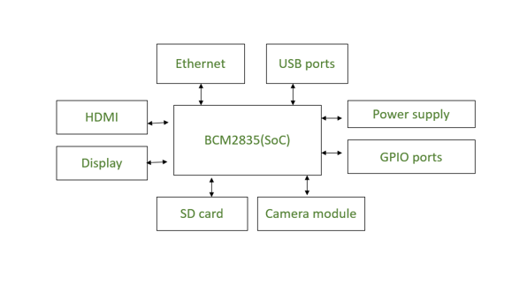

19.5 Working of Raspberry Pi

Step 1: Operating System Installation
An operating system is installed on the SD card.
Examples:
- Raspberry Pi OS
- Ubuntu
- Linux

Step 2: Booting the Device
The Raspberry Pi starts when power is supplied.

Step 3: Program Execution
Programs are written and executed using programming languages.
Example: Python programs for sensor control.

Step 4: Device Interfacing
Sensors and actuators are connected through GPIO pins.

Step 5: Data Processing
The processor processes sensor data.

Step 6: Communication
Data can be transmitted through:
- WiFi
- Bluetooth
- Ethernet

19.6 GPIO Pins in Raspberry Pi
GPIO stands for General Purpose Input Output pins.
Functions:
- Connect sensors
- Connect LEDs
- Control motors
- Read input signals
GPIO pins help Raspberry Pi interact with hardware devices.

19.7 Interfaces in Raspberry Pi

i) SPI (Serial Peripheral Interface): Used for fast communication with sensors and displays.

ii) I2C (Inter-Integrated Circuit): Used for communication between multiple devices using two wires.

iii) UART: Used for serial communication.

iv) USB: Used to connect external devices.

19.8 Advantages of Raspberry Pi

a) Low Cost: Cheap and affordable.

b) Compact Size: Portable and lightweight.

c) Easy to Use: Simple setup and programming.

d) Flexible: Supports many IoT applications.

e) Internet Connectivity: Easy cloud and network integration.

f) Large Community Support: Many tutorials and resources available.

19.9 Disadvantages of Raspberry Pi

a) Limited Processing Power: Less powerful than desktop computers.

b) Limited Memory: Cannot handle very heavy applications.

c) Sensitive Hardware: Can be damaged by incorrect connections.

d) Not Suitable for High-End Computing: Used mainly for embedded and IoT systems.

19.10 Applications of Raspberry Pi

a) Smart Home Automation: Controls lights, fans, and appliances.

b) IoT Projects: Sensor monitoring and cloud communication.

c) Robotics: Robot control and automation.

d) Smart Agriculture: Soil monitoring and irrigation systems.

e) Healthcare Systems: Patient monitoring devices.

f) Industrial Automation: Machine control systems.

19.11 Raspberry Pi vs Desktop Computer
Feature | Raspberry Pi | Desktop Computer
Size | Small | Large
Cost | Low | High
Power Consumption | Low | High
Processing Power | Moderate | High
Portability | Portable | Less portable
Usage | IoT & embedded systems | General computing

19.12 Role of Raspberry Pi in IoT
Raspberry Pi acts as:
- IoT controller
- Data processor
- Communication gateway
- Sensor interface device
It collects sensor data, processes it, and sends it to cloud servers or applications.

19.13 Conclusion
Raspberry Pi is a powerful and low-cost single-board computer widely used in IoT, automation, robotics, and smart systems.
Its GPIO pins, internet connectivity, and easy programming make it highly suitable for modern IoT applications and embedded system development.

20. Smart Home / IoT Case Study

20.1 Definition of Smart Home
A Smart Home is a modern home system in which electrical devices and appliances are connected through the Internet and can be monitored or controlled remotely using smartphones, computers, or voice assistants.

Smart home systems use:
- IoT devices
- Sensors
- Actuators
- Internet connectivity
- Cloud platforms
The main purpose of a smart home is:
- Automation
- Comfort
- Energy saving
- Security
- Remote monitoring

20.2 Components of Smart Home System
Component | Function
Sensors | Detect temperature, motion, light, smoke etc.
Actuators | Perform actions like switching devices ON/OFF
Raspberry Pi / Controller | Controls the system
Internet/WiFi | Provides connectivity
Cloud Server | Stores and processes data
Mobile Application | User controls devices remotely

20.3 Diagram of Smart Home System

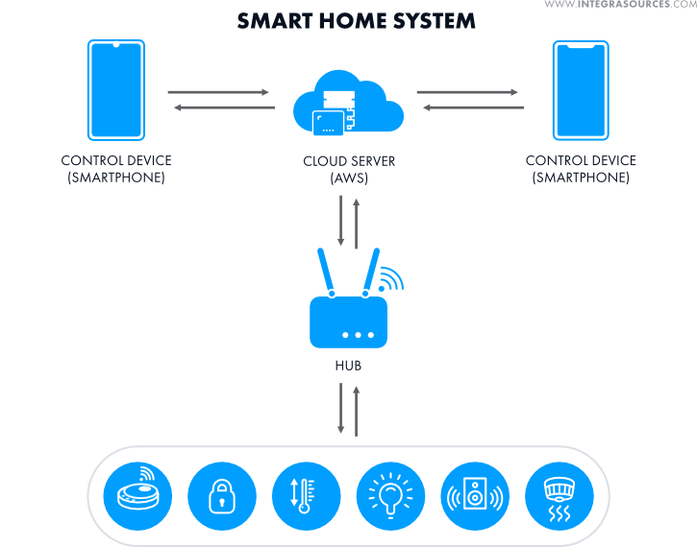

20.4 Working of Smart Home System

Step 1: Data Collection
Sensors collect environmental data.
Examples:
- Motion sensors
- Temperature sensors
- Smoke detectors

Step 2: Data Transmission
Collected data is sent to the controller using:
- WiFi
- Bluetooth
- ZigBee

Step 3: Data Processing
The Raspberry Pi or controller processes the received data.
Example: If room temperature increases, the system decides to turn ON the fan.

Step 4: Action by Actuators
Actuators perform physical actions.
Examples:
- Turning lights ON/OFF
- Opening smart doors
- Controlling air conditioners

Step 5: Cloud Communication
Data is uploaded to the cloud for storage and remote monitoring.

Step 6: User Control
Users can monitor and control devices using:
- Smartphone apps
- Voice assistants
- Web applications

20.5 Devices Used in Smart Home

i) Smart Lights: Automatically controlled lighting systems.

ii) Smart Thermostat: Controls room temperature automatically.

iii) Smart Door Lock: Provides secure entry using mobile apps or passwords.

iv) Smart Camera: Provides home surveillance and security monitoring.

v) Smart Smoke Detector: Detects smoke and fire hazards.

vi) Smart Fans and Appliances: Automatically controlled electrical devices.

20.6 Technologies Used in Smart Home
Technology | Purpose
IoT | Device connectivity
WiFi | Internet communication
Bluetooth | Short-range communication
ZigBee | Low-power communication
Cloud Computing | Data storage and processing
Mobile Applications | User interaction

20.7 Advantages of Smart Home

a) Automation: Devices work automatically.

b) Energy Saving: Reduces unnecessary power consumption.

c) Remote Monitoring: Users can monitor home from anywhere.

d) Improved Security: Smart cameras and locks improve safety.

e) Convenience: Easy control of appliances.

f) Time Saving: Reduces manual work.

20.8 Disadvantages of Smart Home

a) High Initial Cost: Installation can be expensive.

b) Internet Dependency: System depends on internet connectivity.

c) Security Risks: Devices may be hacked if security is weak.

d) Technical Complexity: Requires technical setup and maintenance.

20.9 Applications of Smart Home

a) Smart Lighting Systems: Automatic lighting control.

b) Home Security Systems: Smart locks and CCTV monitoring.

c) Smart Energy Management: Efficient electricity usage.

d) Smart Healthcare: Monitoring elderly or patients at home.

e) Smart Entertainment Systems: Automated TV and music systems.

20.10 Smart Home as an IoT Case Study
Smart Home is one of the best examples of IoT applications because:
- Devices communicate through internet
- Sensors collect real-time data
- Automation reduces human effort
- Users can remotely control appliances
Example Scenario:
- Motion sensor detects movement
- Smart light automatically turns ON
- User receives notification on mobile phone
This demonstrates:
- Sensing
- Communication
- Data processing
- Automation
All core concepts of IoT are used in smart homes.

20.11 Smart Home vs Traditional Home
Feature | Smart Home | Traditional Home
Control | Automatic & remote | Manual
Connectivity | Internet connected | No connectivity
Energy Efficiency | High | Moderate
Security | Smart security systems | Basic security
Monitoring | Real-time | Limited

20.12 Conclusion
A Smart Home is an important IoT application where smart devices communicate through the internet to provide automation, security, energy efficiency, and remote monitoring.
It combines sensors, actuators, controllers, cloud computing, and communication technologies to improve comfort and quality of life.

MUST LEARN TOPICS FOR EXAM :
1. IoT Architecture
2. M2M vs IoT
3. Sensors
4. Actuators
5. RFID
6. WSN
7. ZigBee
8. IEEE 802.15.4
9. MQTT
10. CoAP
11. AMQP
12. Security in IoT
13. Vulnerabilities + Attacks
14. Data Analytics
15. Raspberry Pi
16. Smart Home Case Study

